

**UNIVERSITY OF CALCUTTA**

PROJECT WORK, B.Sc. 6th SEMESTER (H)

CARS PRICE ANALYSIS : OPTIMIZING CAR PRICES FOR BUYERS AND SELLERS

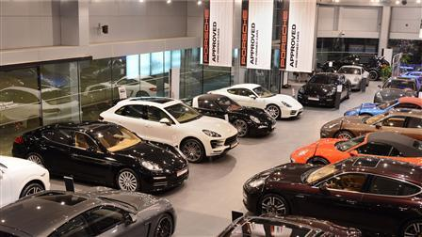

UNIVERSITY ROLL NO. : 203012-21-0166

UNIVERSITY REGISTRATION NO. : 012-1111-0977-20

SUBJECT : STATISTICS (H)

PAPER : DSE-B2

SESSION : 2023